Introduction:
In broad scene, generally commercial buses are divided into two classes viz; bus and coach.Buses are used for carrying large number of people over short distances in a dense traffic. Not much space is provided for luggage, but there is adequate visibility for the passengers to know where they have to get down. Usually there are two doors, the one at the rear for mounting and the one at the front for getting down. Sometimes, the buses have two floors. Such buses are known as the double-decker buses. Coaches are used for transporting passengers over long distances and are therefore provided with luxurious interior with comfortable, adjustable seats and amenities like video.
Commercial buses in Nepal:
In Nepal, for city ride generally mini buses are proffered having a single door having only one door creating problems to the passenger while mounting as well as getting down. Although the buses are having 25 to 30 seats, these buses carry more than the capacity at the peak passenger time that is at the office time creating more problem to the passenger in the travel as well as while mounting andgetting down, this ultimately increases the time taken in the journey.
For transporting passengers over long distances both day and night coaches are found in Nepal. During the mini buses are also found in Nepal which mainly departs from the capital to the nearer city of the country viz;, Narayangardh, Butwal, Bhaairahawa, Pokhara, Birgunj etc. the long distance buses in nepal are of different standards having different body design and seat standards. Generally the buses are having folding seats and provided with spaces for the luggage.
Chassis:
The chassis combines:
- A structural under frame
- Engine and radiator
- Gearbox and transmission
- Wheels, axles and suspension
- Dashboard and steering wheel and driver's seat
Chassis will often be built as complete units, up to the point of being drive-able around the factory, or on the public highway to a nearby bodybuilder. The chassis will usually be front-engine, mid-engine or rear engine. Most chassis will mount the radiator at the front, irrespective of engine position, for more efficient cooling.
Chassis products will often be available in different standard lengths, and often be used for both bus and coach bodywork. The same chassis may even be used for single or double-decker bus bodywork. Chassis builders may also offer different options for gearbox and engine suppliers. Chassis may also be built in multiple axle configurations.
Bodywork
Bodywork is built for three general uses:
- Bus
- Dual Purpose
- Coach
Bus bodywork is usually geared to short trips, with many transit bus features. Coach bodywork is for longer distance trips, with luggage racks and under-floor lockers. Other facilities may include toilets and televisions. A dual purpose design is usually a bus body with upgraded coach style seating, for longer distance travel. Some exclusive coach body designs can also be available to a basic dual purpose fitment.In past double-deck designs; buses were built to a low bridge design, due to overall height restrictions.
Major factors to be considered for body design:
The bus body builder will build the body onto the chassis. This will involve major consideration of:
- purpose
- Seating capacity
- Staircase position/design (double-decker buses)
- Number and position of doors
The purpose of the bus is of prime importance while designing the body of the bus. It must be noted that weather it is a short distance city bus or a long distance luxurious coach. Another factor playing important role in the design of the body is the sitting capacity desired. Besides these two factors staircase position and their design should also be decided in advance.Body-on-frame
Types of bus body construction:
There are basically two types of body construction
- Unibody construction:
The unibody differs from the frame in that it is actually stamped out as part of the body structure. Also referred to sometimes as unitized construction, today’s automobiles most commonly use the unibody design because it’s inherent ability to absorb energy during a collision. Most light trucks continue to use body-on-frame construction. Even though a car or light truck is usually built one way or the other, there are some vehicles that use a partial frame (sometimes called a sub-frame) along with unibody construction.
- Body on frame construction
In Nepal the long distance commercial buses are of body on frame type. Hence this report is primarily based on body design on frame construction.
Chassis manufacturer builds the under frame in a body-on-frame type construction and the body manufacturer builds the coachwork a body-on-frame type construction. The splitting of body and chassis construction allows companies to specialize in two different fields. It also allows differing offerings of product to customers, who might prefer different chassis/body combinations. For the manufacturers it lessens the exposure if one or the other goes out of business. Larger operators may also split orders between different body/chassis combinations for shorter delivery schedules.
Body on frame
Body-on-frame is an automobile construction technology. Mounting a separate body to a rigid frame which supports the drive train was the original method of building automobiles, and its use continues to this day. The original frames were made of wood (commonly ash), but steel ladder frames became common in the 1930s.
Most small passenger vehicles switched to Body Frame Integral construction in the 1960s, leaving just trucks, some bus manufacturers and large cars using conventional frames. The switch continued for several decades - even small SUVs typically use unibody construction today. Body-on-frame remains the preferred construction method for heavy-duty commercial vehicles, especially those which are intended to carry and pull heavy loads, such as trucks.

Advantages and disadvantages compared to unibody

Advantages
- Easier to design, build and modify (less of an issue now that CAD is commonplace, but still an advantage for coachbuilt vehicles).
- More suited for heavy duty usage and can be more durable.
- Easier to repair after accidents.
- Overall better ride quality for SUVs.

Disadvantages
- Heavier than unibody - lower performance and/or higher fuel consumption.
- Center of gravity is usually higher - compromising stability and handling.
- Less resistant to torsion (flexing of the whole car in corners) - compromising handling and road holding.
- No crumple zone - higher rate of death and serious injury.
- Higher production costs.

General design issues
Bus manufacturers have to have consideration for some general issues common to body, chassis or integral builders.
- Maximum weight (laden and unladen)
- Stability - often a tilt test pass is required
- Maximum dimensions - length and width restrictions may apply
- Fuel consumption
- Emissions standards
- Accessibility
In the 1990s onwards, some bus manufacturers have moved towards making transit bus interiors more comparable to private cars, to encourage public transport ridership. Other additions have seen multimedia and passenger information systems, and CCTV systems. With these developments, bus designs have been increasing in weight, which is a concern for operators with the rising price of fuels in the 2000s.

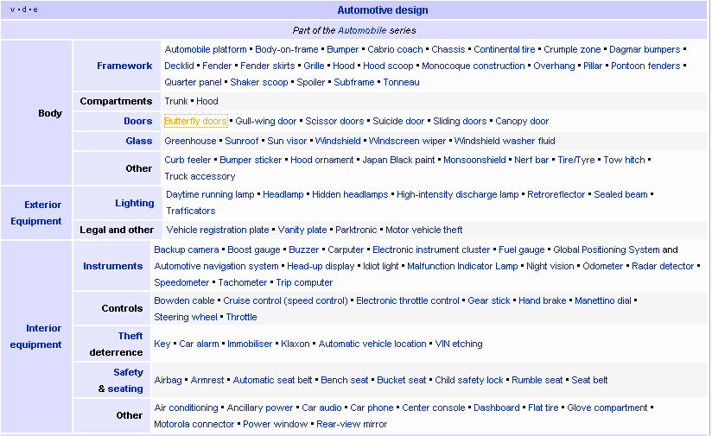
Body side structure design:
Recently, significant efforts have been made by auto understandmotive
manufacturers to meet the increasing need to reduce production costs and improve fuel efficiency Weight reduction of vehicle body structures is pursued as one of the solutions to meet the requirements, and the lightweight design of autobody structures has becomean important issue for this purpose [2–6]. In order to achieve a significant reduction in vehicle weight, two aspects need to be considered
- the application of alternative lighter materials such as aluminum and composites replacing conventional steels
- a reduction in the number and weight of parts in the whole body structure without replacing steel
This is concerned with the latter, which not only reduces the production cost reasonably but also avoids extra tooling investments due to the replacement of material and the corresponding changes in joining technology. However, simple modification of structural parts may be limited by the body strength, stiffness and crashworthiness. Therefore, an understanding of the detailed strength and stiffness distribution in a body is important for attaining optimization in weight reduction design and effective structural strength and rigidity. The finite element (FE) method has usually been employed as a means to this end and is validated by experimental studies. It adopts a non-load-supporting structural frame on a specialized bus chassis, described as having good seating comfort and aesthetic appearance. In order to ensure both the required reliability of body performance and efficient use of material, a synthetic comparative study on body rigidity and strength, load-carrying capacity and design optimization has been carried out with combined theoretical and experimental approaches. This is done by analyzing the difference in load-carrying capacity (rigidity and strength) between an actual bus body and a modified design structure (that has a number of skewed supporting rods connecting the long longitudinal beams at the waist part of the sides removed). The vibration modes between the alternative structures are analyzed Optimization,and,sensitivity analysis are carried out.
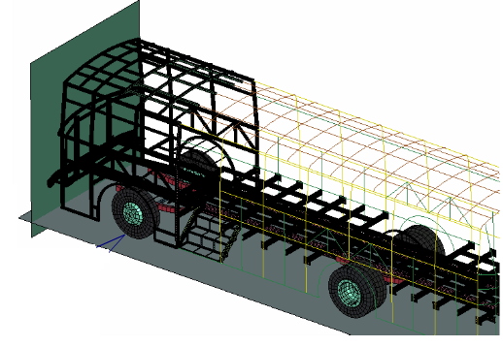
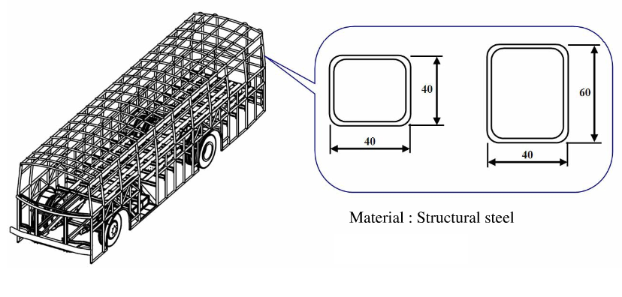

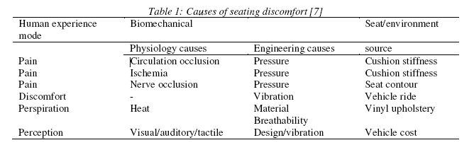
Factors to be considered while seat design:
VIBRATION APPROACH
A major portion of the vibrations experienced by the occupants of an automobile enters the body through the
seat . Whole-body vibrations, which are mainly vertical vibrations, tend to affect the human body the most.
These vibrations are transmitted to the buttocks and back of the occupant along the vertebral axis via the base
and back of the seat . Since the natural frequency for the human trunk falls in the range of 4-8 Hz, it is
expected that the whole-body vibrations that will most largely affect passengers will occur in this frequency range.
PRESSURE APPROACH
Seat comfort is as important as the functional and aesthetic design of automobiles since consumers are more
and more concerned about safety and comfortable driving and travelling. Enhancement of comfort performance of automotive seats necessitates considerations of the human-seat interface pressure distribution under dynamic vibration environment.
MEDICAL APPROACH
Johnson and Neve examined structural properties of automobile seats that might be a source of lower lumbar pain (LBP) .
MECHANICAL RESEARCH
Mechanical research on vehicle seats concentrated on the actuators, the suspensions and dampers. Liu and
Wagner designed the controllers and evaluated semi-active hydraulic and active electromechanical hydraulic actuators. A series of four model-free and model based control strategies are presented for each actuator to attenuate road vibrations transmitted to the occupant’s lower and upper torso. The controller designs include relative, proportional-integral, variable structure system, and optimal control. Perisse and Jezequel published a paper over viewing a theoretical study on active seat suspension. The principal objective of this study is to improve ride passenger comfort by reducing transmitted seat forces.

Window design:

Mainly design consist of two parameter
1) Air flow
2) Lighting or viewing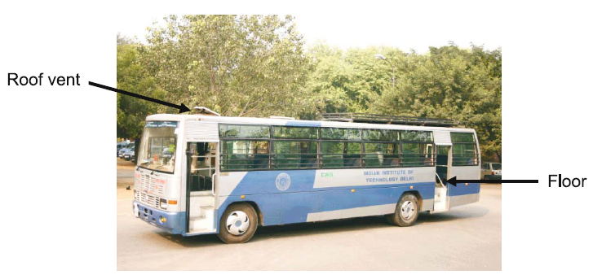

Passenger side windows shall be provided throughout the passenger area (T-slider). These windows will be a horizontal opening type. These windows shall meet all the latest federal regulations for retention and release. Kick-out type windows will be hinged at the top. All windows that are considered as emergency exits will be clearly marked. A full-length drip molding approximate 3/4" will be installed. The ventilation section of the window shall be located at the top so seating does not interfere with operation. Passenger windows will be approximately 40" x 29".
The driver position, on buses with right hand front entrance door only, shall have a window that can be opened for ventilation at the left side.
The dual right hand passenger entrance doors shall have full-length windows that will allow the driver to judge curb locations.
The emergency rear door shall have upper and lower fixed glass with a red light and signage denoting use as an emergency exit.
There will be glass on each side of the emergency door, approximately 6" x 30".
The windshield, driver position side window, and rear emergency door glass will be tinted.
The passenger entrance door glass will be tinted in the upper part and may be clear in the lower part.
All passenger area side window glass will be tinted. An approximate tinting of 28%-30% light transfer is acceptable in side glass.
All sliding side windows will have inside latches for security. All windows, doors, and windshield will be installed to keep water and dust leakage to a minimum. All doors and side windows will have a 3/4" drip molding installed over them

